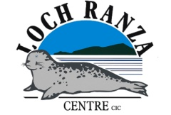

Lochranza Field Centre Site Specific Risk Assessment: Problem Solving

Date: 22/01/2019
Where Hazards have been identified as Generic to all activities the controls are specified within the Generic Instructing Standards
Where Hazards have been identified as Generic to all Land activities the controls are specified within the Generic Land Risk

Hazards  (please specify) | Existing Control Measures  (please specify if present) | Residual Risk Level  (Insert values and multiple  score : see key )
 |  | Low | Med | High
Blind Folds. Slips, trips and falls caused by guest being blind folded. | Guests only to use blind folds for approved activities using trained procedures as per the SSOP. | 3X1 = 3
Archery. Injury from arrows. | When an Archery session is taking place the Instructor will brief the guests on the hazard and what areas are ‘out of bounds’. | 5x1 = 5
Soil, sheep and deer droppings. Illness caused by ingestion. | Instructor to brief group on risks. Group encouraged to wash hands after session. | 2x1 = 2

(Key: 1-7 = Low Risk; 8-15 = Medium Risk; 16-25 = High Risk)

Endorsed by: Chris Trail, Centre Operations Manager

Date: 22/01/2019

